Bangkok 3Day2Night

Hight light: Dannea saduk floating Market / Songwat road Street art & food

Complementary coconut drink or Mango sticky rice

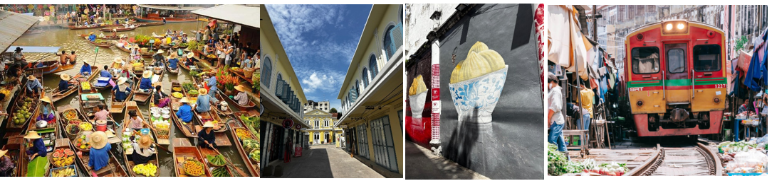

Booking code BKK-3D

3D2N Bangkok & Surroundings Tour

Day 1 – Arrival-Hotel

Arrival at Bangkok airport by representative at the airport. Transfer to hotel and check-in

Day 2 – Damnoen Saduak Floating Market & Maeklong Railway Market / Sonwat Art Street

- Breakfast at hotel

- Depart for Damnoen Saduak Floating Market – enjoy boat rides, local food, and souvenirs

- Visit Maeklong Railway Market – experience the unique train passing through the market

- Return to Bangkok, Visit Songwat Art Street – explore street art, local galleries, and cafes

- Platinum mall, Big Ce super market, Free time in the evening for shopping or leisure

- Evening at leisure or optional night market visit

Overnight in Bangkok

Day 3 – Departure

- Breakfast at hotel

- Free time for last-minute shopping or sightseeing

- Transfer to airport for departure

